Social-Emotional Competencies

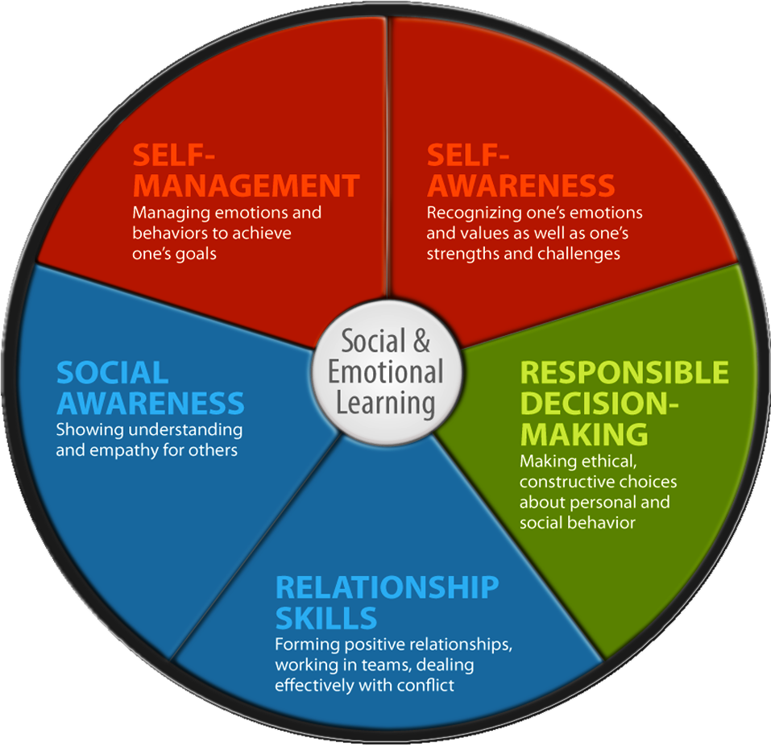

Borrowed from http://www.csus.edu/ccr/Social%20and%20Emotional%20Learning/

